**Nom**:________________

**PLANNING SETMANAL - MATÍ -**

|  |  |  |  |  |  |  |  |
| --- | --- | --- | --- | --- | --- | --- | --- |
|  | **L** | **M** | **X** | **J** | **V** | **S** | **D** |
| **7.00** |  |  |  |  |  |  |  |
| **8.00** |  |  |  |  |  |  |  |
| **9.00** |  |  |  |  |  |  |  |
| **10.00** |  |  |  |  |  |  |  |
| **11.00** |  |  |  |  |  |  |  |
| **12.00** |  |  |  |  |  |  |  |
| **13.00** |  |  |  |  |  |  |  |
| **14.00** |  |  |  |  |  |  |  |

|  |  |  |  |  |  |  |  |
| --- | --- | --- | --- | --- | --- | --- | --- |
|  | **L** | **M** | **X** | **J** | **V** | **S** | **D** |
| **15.00** |  |  |  |  |  |  |  |
| **16.00** |  |  |  |  |  |  |  |
| **17.00** |  |  |  |  |  |  |  |
| **18.00** |  |  |  |  |  |  |  |
| **19.00** |  |  |  |  |  |  |  |
| **20.00** |  |  |  |  |  |  |  |
| **21:00** |  |  |  |  |  |  |  |
| **22.00** |  |  |  |  |  |  |  |

**PLANNING SETMANAL - TARDA -**

**IMATGES**

20´ DEBERES

30´ TRABAJO





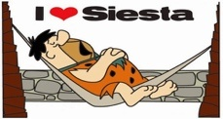













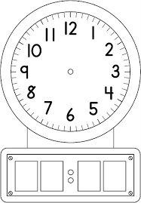



















**PLANNING SETMANAL-TARDA -**